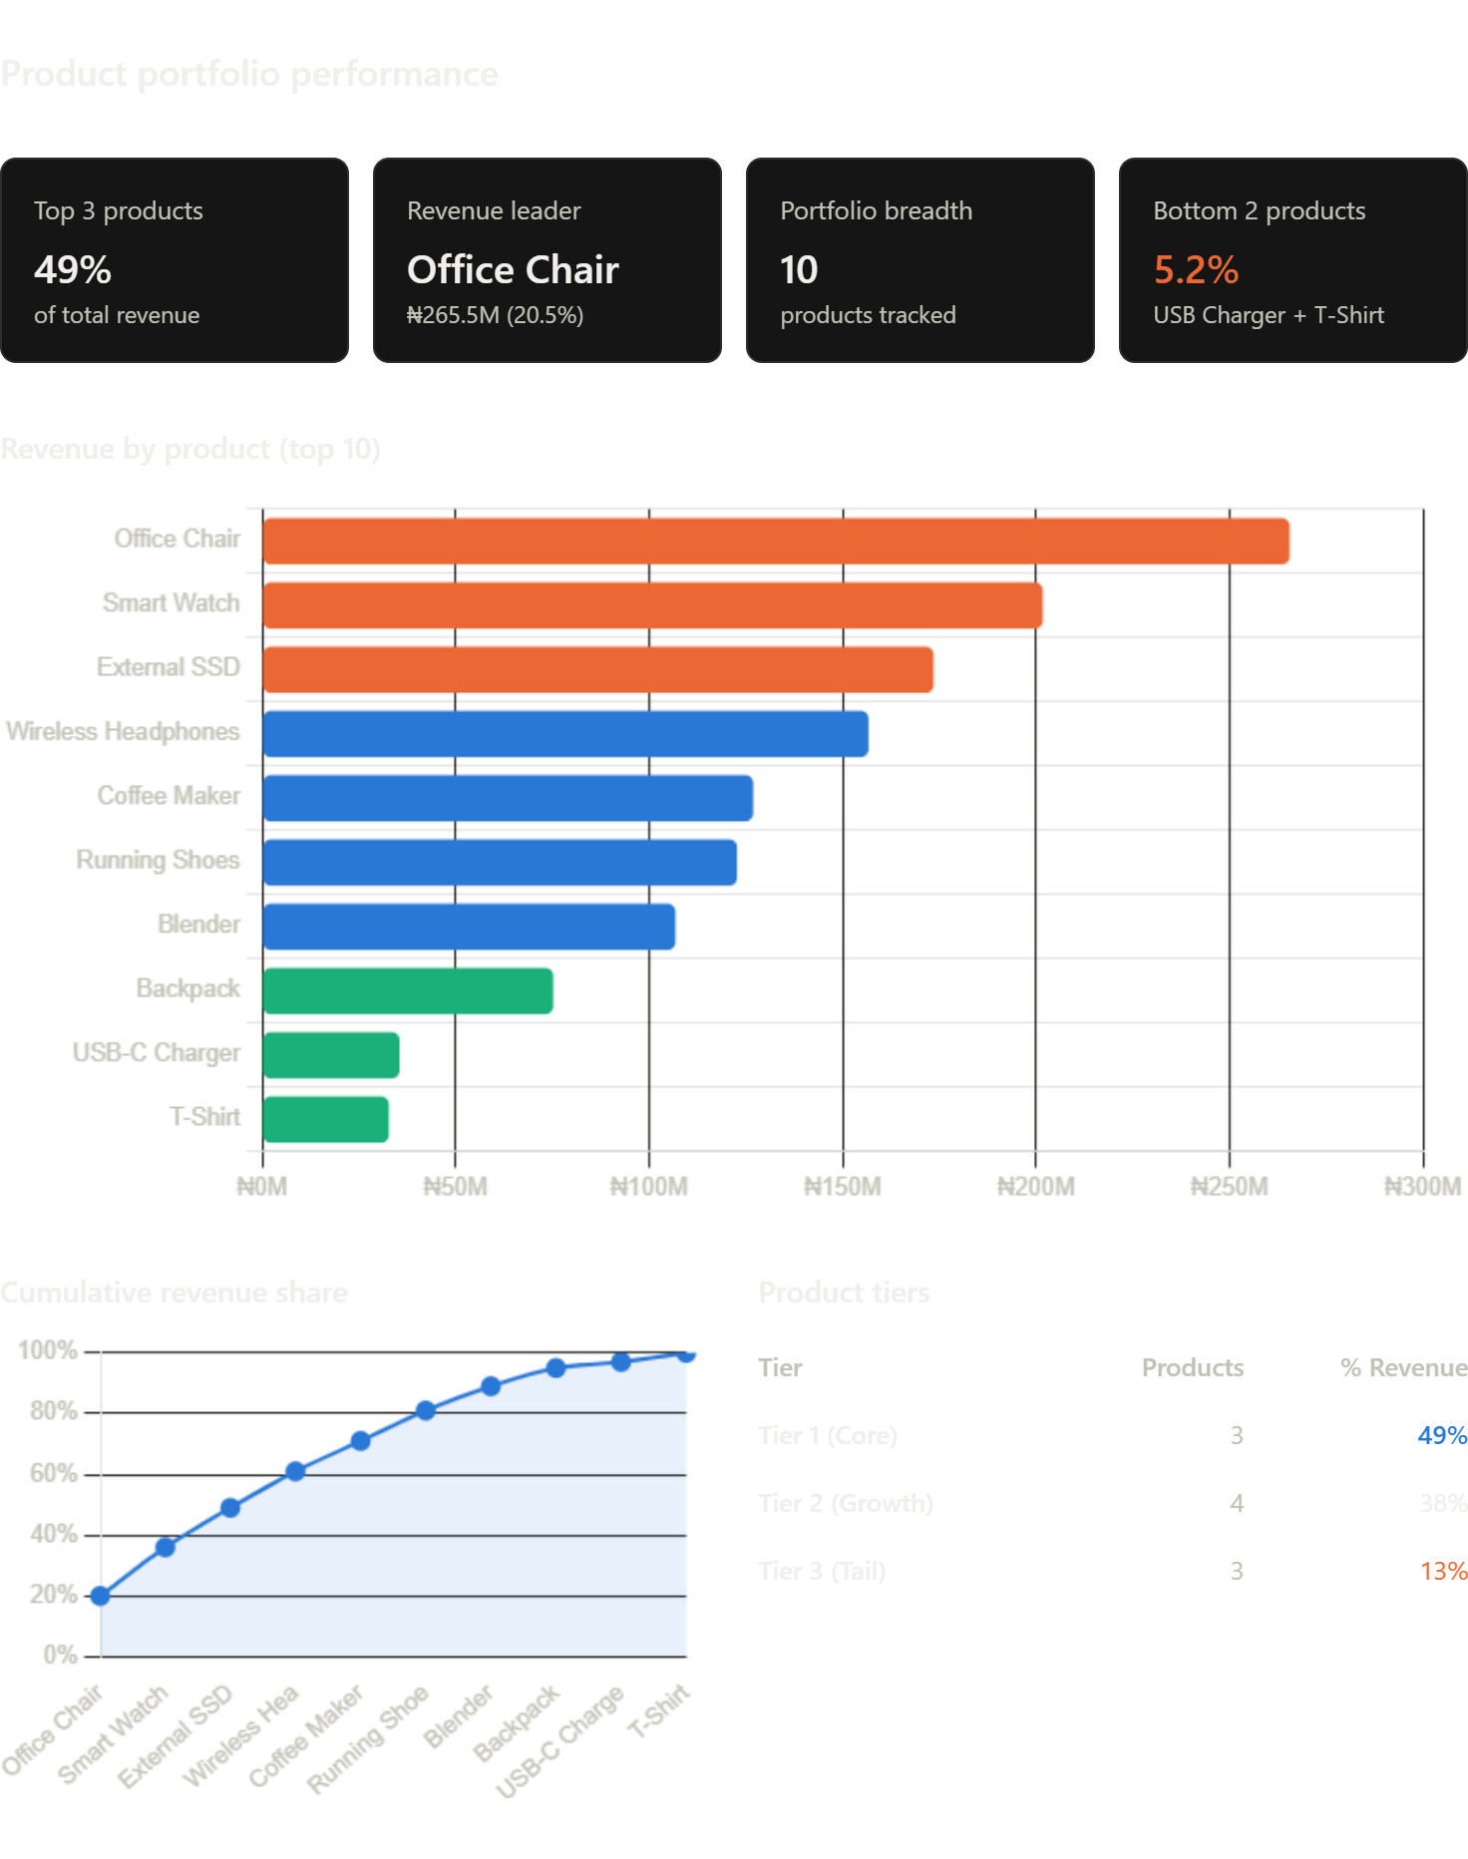

The ecommerce business runs on three products. They generate nearly half the revenue. This is both our greatest asset and biggest vulnerability.

Tier 1 (The Core) - 49% of revenue, 3 products - Office Chair: ₦265.5M (20.5%), Smart Watch: ₦201.7M (15.5%), External SSD: ₦173.5M (13.4%)
These three are profit engines. They're mature, proven, and generating predictable cash while carrying existential risk - any supply disruption, competitors move, or demand shock threaten half the business.
Tier 2 (The Growth Plays) - 38% of revenue, 4 products - Wireless Headphones: ₦156.7M (12%), Coffee Maker: ₦126.9M (10%), Running Shoes: ₦122.7M (9.5%), Blender: ₦106.8M (8%)
Tier 3 (The Tail) - 13% of revenue, 3 products - Backpack: ₦75.3M (5.8%), USB-C Charger: ₦35.5M (2.7%), T-Shirt: ₦32.8M (2.5%). USB Charger and T-Shirt each generate less revenue than a single day's Office Chair sales.

Critical Business Risks
1. Single-Vendor Dependency (Likely)
If Office Chair comes from one supplier and that supplier faces disruption (port strike, factory fire, geopolitical), you lose ₦265M-20% of total revenue. Do you have a backup supplier at the same cost/quality? If not, this is catastrophic risk.

2. Category Concentration
Office Chair and Wireless Headphones are Electronics/Office, Smart Watch and External SSD are Tech, Coffee Maker and Blender are Appliances, Running Shoes are Fashion, etc.
The top 3 are office/tech - heavy. If corporate spending cools (recession) or remote work adoption plateaus, 50% of the revenue is at risk simultaneously.

3. Margin Unknown
Office Chair generates ₦265M revenue. But:
- Is it ₦1000/unit × 265k units or ₦50,000/unit × 5.3k units?
- What's the margin-40% or 10%?
- What's the return rate and cost of logistics?
A high-volume, low-margin play (e.g., 10% margin) is riskier than a low-volume, high-margin play (e.g., 50% margin). You must analyze profitability by product, not just revenue.

Untapped Opportunities
4. Tier 2 Scaling Problem
Wireless Headphones generates ₦156.7M-a strong product. But it's 40% below Smart Watch and 59% below Office Chair. Why?
Possible reasons:
- Positioning: Headphones are treated as accessories, not core products
- Pricing: Headphones might have lower price points (₦5–10k) vs. Office Chair (₦50–100k+)
- Marketing: Tier 1 gets budget focus; Tier 2 is neglected
- Availability: Limited stock or limited store placement?

5. Tier 3 Cleanup
USB-C Charger and T-Shirt combined = ₦68M revenue. That's $68M in SKU management cost, warehouse space, inventory holding, and supply chain complexity for 5.2% of revenue.
Question: Could you redirect that 5.2% (plus staff time saved) into scaling Tier 2?

Strategic Recommendations
Issue # | Priority | Finding | Impact | Timeframe
1 | Critical | Map supply chains for top 3 products | Identify single points of failure to mitigate supply risk | 2 weeks
3 | Critical | Analyze margins by product | Understand true profitability and reveal hidden losses or opportunities | 2 weeks
1 | High | Develop backup suppliers for Office Chair/Smart Watch | Reduce supply risk and increase resilience | 2-4 weeks
4 | High | Scale Wireless Headphones to ₦200M+ | It's 60% of the way there with possible ₦40-50M new revenue | 2-4 weeks
5 | High | Discontinue USB-C Charger + T-Shirt if not profitable | Free up ₦68M inventory + management overhead (simplify + re-invest) | 2-4 weeks
5 | Medium | Run profitability drill: revenue vs. margin by product | It might reveal Tier 3 is high margin aiming at reprioritizing revenue | 4 weeks +
4 | Medium | Expand Coffee Maker / Running Shoes (both strong performers) | They're close to Headphones; close gap with possible revenue upside of ₦20-30M each | 4 weeks +

